Waste Management is a lucrative business In Rivers State

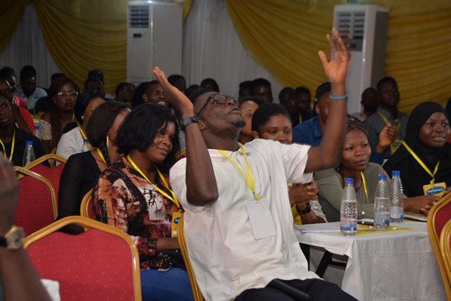

How will you feel if your teacher throws a question at the class and someone he called before you gave out the answer you have in mind? Painnnn… you have to quickly think of another answer or simply rephrase what you have in mind.

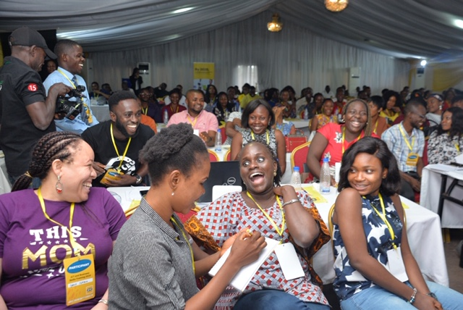

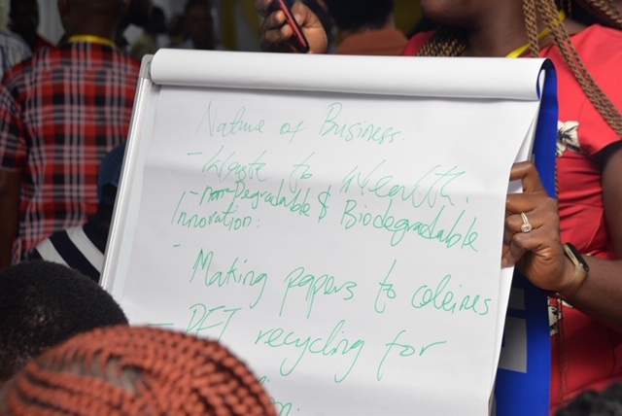

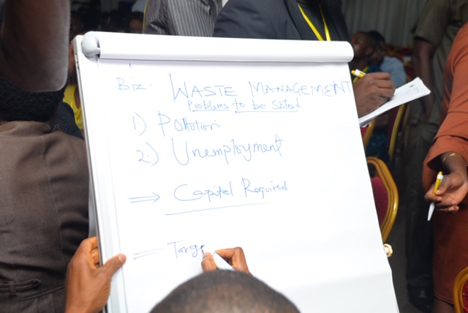

There was a similar case at the ICT & Business Skills training in Port Harcourt, the two-day training organised by MTN Foundation had 500 participants comprising of business owners and ICT enthusiasts in attendance. After several sessions from Google Digital Skills Trainer, Destiny Takon and Assistant Manager, KPMG Technology Advisory, Tosin Okuselu, it was time for a brief task.
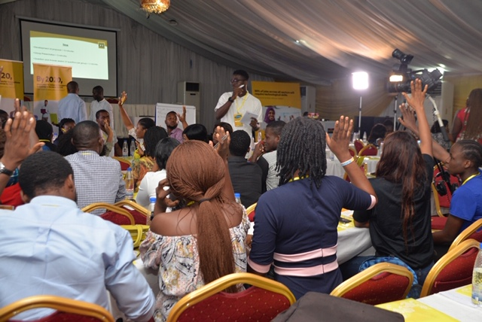
A mini competition was also organized to test business development capability of participants. They were divided into groups and asked to develop a business proposal and present their ideas after brainstorming for 15 minutes.

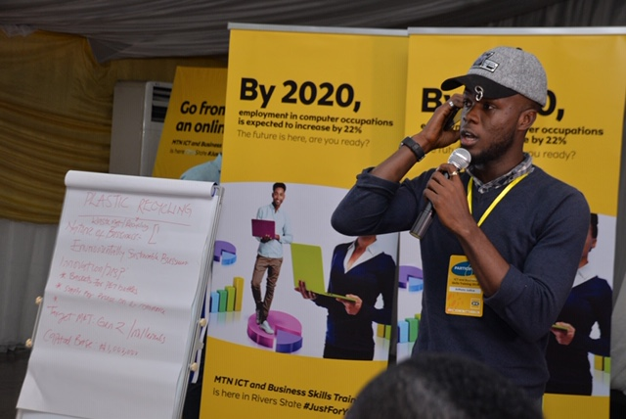

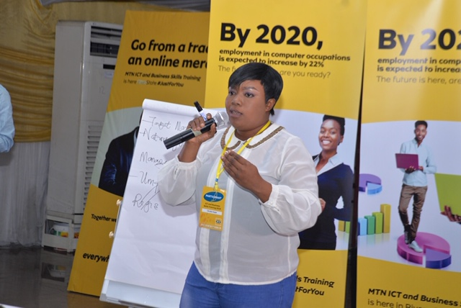

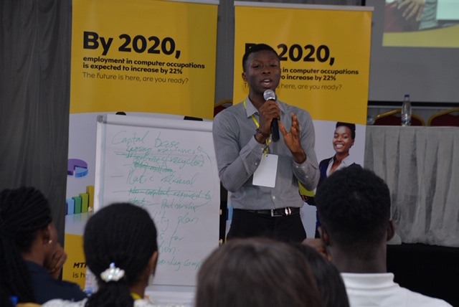

15 minutes later, they all had an interest in waste management and recycling and presented different tactics related to the same business plan, the hall was buzzing with laughter as to how all groups came about the same business idea.

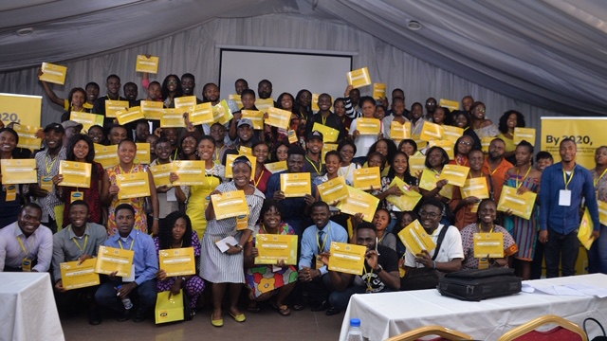
Regardless, they were all winners! Not only did they go home with the knowledge of ICT and Business Skills, some outstanding guests left the conference hall with exciting gifts that will always remind them that MTN Nigeria cares. #MTNICTBizTrainingPH
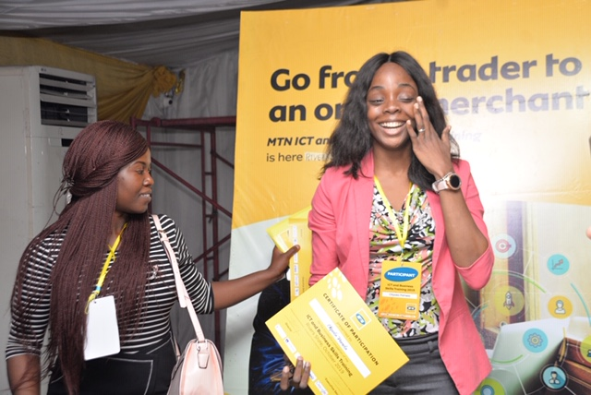

----END---

